Metro East Illinois SHRM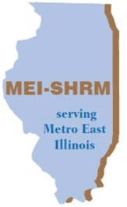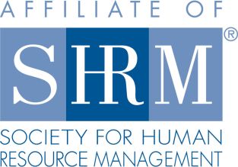
Affiliate of the Society for Human Resource Management
Sponsorship Application
Metro East Illinois SHRM offers an opportunity to reach key HR decision makers through sponsorship of MEI-SHRM meetings. Now more than ever, it is critical to market your company and its services to the right people: the decision makers. MEI-SHRM members and meeting attendees include HR professionals at local, regional, state, and national levels – and represent a robust cross-section of local industries.

Benefits of Sponsorship
Exposure
MEI-SHRM Sponsorship enables your business to expand visibility in the Metro East market – allowing you the opportunity to inform decision makers and influential professionals about your products and services. Sponsor representatives will be allowed 5 minutes at one of our monthly meetings (mutually agreed upon date) to share information about their business/product, distribute promotional material to meeting attendees, and network with local business leaders to deliver insight and credibility to their brand.
Recognition
Sponsors have the opportunity to promote their business and product(s) to influential business professionals.
Participation
Sponsors are allowed business promotion and networking opportunity at a designated monthly MEI-SHRM meeting.
Sponsors are required to fund (and/or provide) the lunch meal for one (1) designated lunch meeting per year.
Sponsorship Levels
Sponsorship Level | Annual Fee | Promotional Opportunity
Silver Sponsor | $100 | - Five minute presentation/business overview to kick-start the designated sponsorship meeting  - Distribute promotional materials at designated sponsorship meeting
Gold Sponsor | $200 | - Company logo included on meeting programs & electronic meeting promotional communications  - Five minute presentation/business overview to kick-start the designated sponsorship meeting  - Distribute promotional materials at designated sponsorship meeting
Platinum Sponsor | $500 | - Company logo included on MEI-SHRM website for one year – Company highlighted as official sponsor and partner of MEI-SHRM  - Company logo included on meeting programs & electronic meeting promotional communications  - Five minute presentation/business overview to kick-start the designated sponsorship meeting  - Distribute promotional materials at designated sponsorship meeting

Please contact Danielle at programming@mei-shrm.com with any questions.

Contact Name: __________________________________ Company: ________________________________

Sponsorship Level (select one): Silver $100 Gold $200 Platinum $500

Phone: ______________________________ Email: _________________________________________

Meeting presentation/lunch sponsorship date preference (if any): _____________________________________

Payment Method:

- Credit Card Type: ________________________________________ Sec Code:_______________
Card #: ___________________________________________________________ Exp Date: ________
Name as it appears on Card: ____________________________________________________________
Zip code of card billing address: __________________
- Credit Card Payment in person at next membership meeting
- Check payable to Metro East Illinois SHRM

Please submit the completed sponsorship form and payment at an upcoming meeting or mail to:

Metro East Illinois SHRM
PO Box 3
Collinsville, IL 62234

